BÁO CÁO THỰC HÀNH
IT3280 – 147793 – THỰC HÀNH KIẾN TRÚC MÁY TÍNH
Tuần 04: ARITHMETIC AND LOGICAL OPERATION
Họ và tên | Lê Đồng Cảnh Phú
Mã số sinh viên | 20225755

Assignment 1
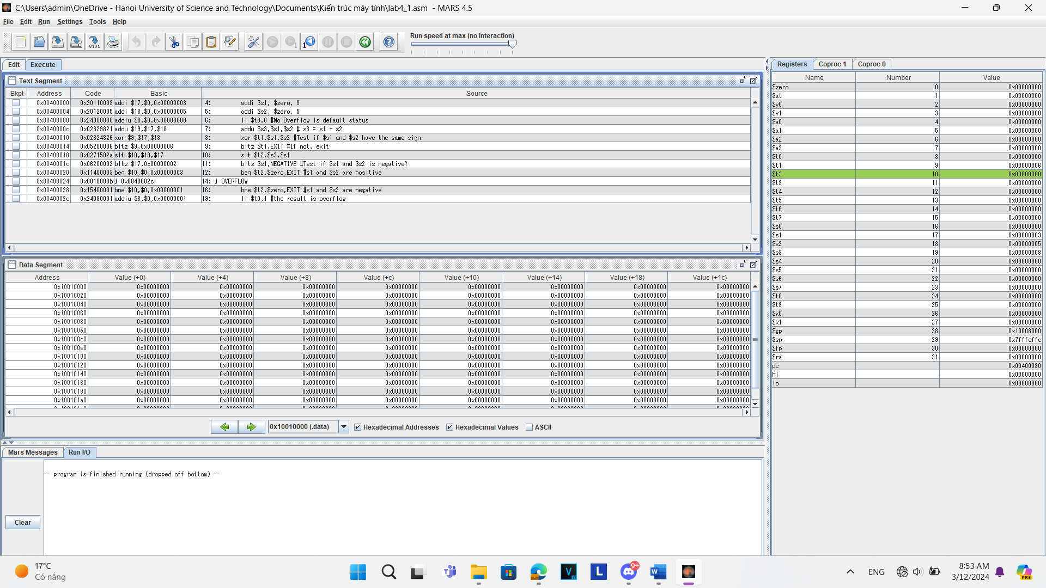
TH1: s1, s2 cùng dấu
- Chọn s1=3, s2=5
- Bảng trạng thái
Trạng thái chạy | Nội dung của thanh ghi
Trạng thái chạy | $s1 | $s2 | $s3 | $t0 | $t1 | $t2 | pc
Ban đầu | 0x00000000 | 0x00000000 | 0x00000000 | 0x00000000 | 0x00000000 | 0x00000000 | 0x00400000
Chạy lệnh addi thứ 1 | 0x00000003 | 0x00000000 | 0x00000000 | 0x00000000 | 0x00000000 | 0x00000000 | 0x00400004
Chạy lệnh addi thứ 2 | 0x00000003 | 0x00000005 | 0x00000000 | 0x00000000 | 0x00000000 | 0x00000000 | 0x00400008
Chạy lệnh li | 0x00000003 | 0x00000005 | 0x00000000 | 0x00000000 | 0x00000000 | 0x00000000 | 0x0040000c
Chạy lệnh addu | 0x00000003 | 0x00000005 | 0x00000008 | 0x00000000 | 0x00000000 | 0x00000000 | 0x00400010
Chạy lệnh xor | 0x00000003 | 0x00000005 | 0x00000008 | 0x00000000 | 0x00000006 | 0x00000000 | 0x00400014
Chạy lệnh bltz thứ 1 | 0x00000003 | 0x00000005 | 0x00000008 | 0x00000000 | 0x00000006 | 0x00000000 | 0x00400018
Chạy lệnh slt | 0x00000003 | 0x00000005 | 0x00000008 | 0x00000000 | 0x00000006 | 0x00000000 | 0x0040001c
Chạy lệnh bltz thứ 2 | 0x00000003 | 0x00000005 | 0x00000008 | 0x00000000 | 0x00000006 | 0x00000000 | 0x00400020
Chạy lệnh beq | 0x00000003 | 0x00000005 | 0x00000008 | 0x00000000 | 0x00000006 | 0x00000000 | 0x00400030

- Chọn s1=2, s2=2147483648
- Bảng trạng thái
Trạng thái chạy | Nội dung của thanh ghi
Trạng thái chạy | $s1 | $s2 | $s3 | $t0 | $t1 | $t2 | pc
Ban đầu | 0x00000000 | 0x00000000 | 0x00000000 | 0x00000000 | 0x00000000 | 0x00000000 | 0x00400000
Chạy lệnh addi thứ 1 | 0x00000002 | 0x00000000 | 0x00000000 | 0x00000000 | 0x00000000 | 0x00000000 | 0x00400004
Chạy lệnh addi thứ 2 | 0x00000002 | 0x7fffffff | 0x00000000 | 0x00000000 | 0x00000000 | 0x00000000 | 0x00400010
Chạy lệnh li thứ 1 | 0x00000002 | 0x7fffffff | 0x00000000 | 0x00000000 | 0x00000000 | 0x00000000 | 0x00400014
Chạy lệnh addu | 0x00000002 | 0x7fffffff | 0x80000001 | 0x00000000 | 0x00000000 | 0x00000000 | 0x00400018
Chạy lệnh xor | 0x00000002 | 0x7fffffff | 0x80000001 | 0x00000000 | 0x7ffffffd | 0x00000000 | 0x0040001c
Chạy lệnh bltz thứ 1 | 0x00000002 | 0x7fffffff | 0x80000001 | 0x00000000 | 0x7ffffffd | 0x00000000 | 0x00400020
Chạy lệnh slt | 0x00000002 | 0x7fffffff | 0x80000001 | 0x00000000 | 0x7ffffffd | 0x00000001 | 0x00400024
Chạy lệnh bltz thứ 2 | 0x00000002 | 0x7fffffff | 0x80000001 | 0x00000000 | 0x7ffffffd | 0x00000001 | 0x00400028
Chạy lệnh beq | 0x00000002 | 0x7fffffff | 0x80000001 | 0x00000000 | 0x7ffffffd | 0x00000001 | 0x0040002c
Chạy lệnh j OVERFLOW | 0x00000002 | 0x7fffffff | 0x80000001 | 0x00000000 | 0x7ffffffd | 0x00000001 | 0x00400034
Chạy lệnh li thứ 2 | 0x00000002 | 0x7fffffff | 0x80000001 | 0x00000000 | 0x00000001 | 0x00000001 | 0x00400038

Assignment 2
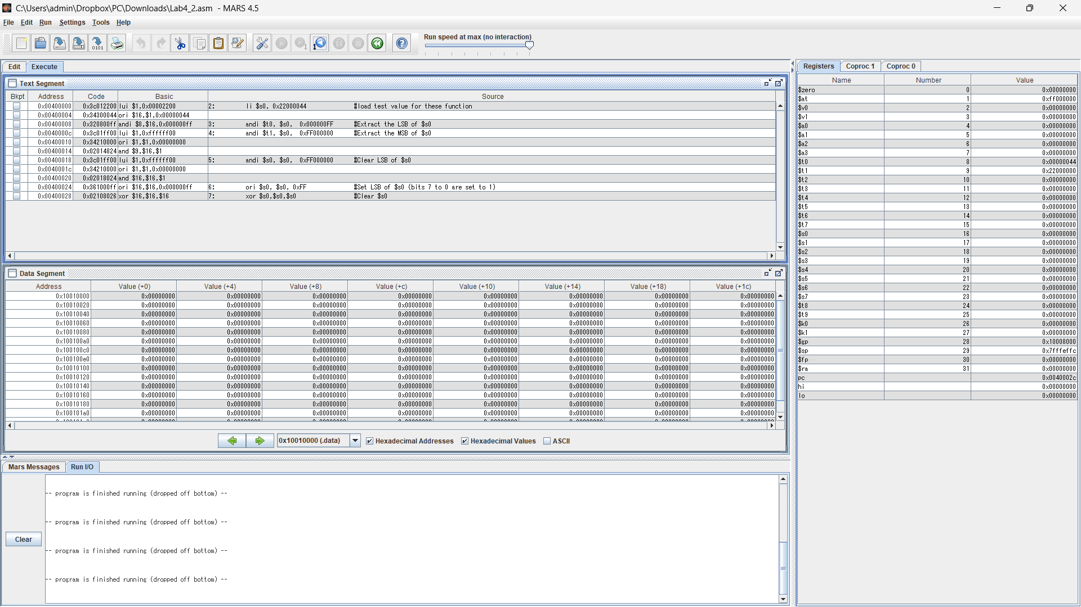
.text
li $s0, 0x22000044 #load test value for these function
andi $t0, $s0, 0x000000FF #Extract the LSB of $s0
andi $t1, $s0, 0xFF000000 #Extract the MSB of $s0
andi $s0, $s0, 0xFF000000 #Clear LSB of $s0
ori $s0, $s0, 0xFF #Set LSB of $s0 (bits 7 to 0 are set to 1)
xor $s0,$s0,$s0 #Clear $s0

Assignment 3
a,
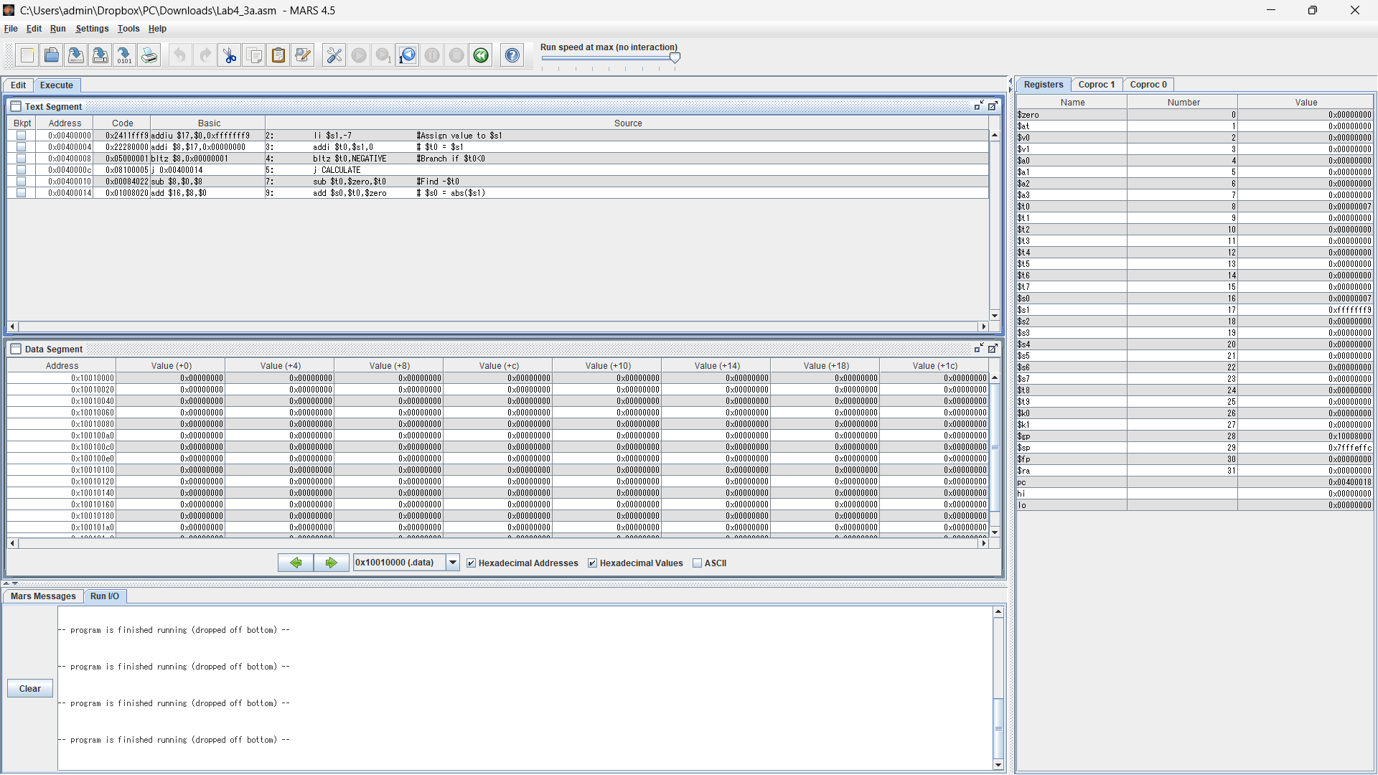
.text
li $s1,-7 #Assign value to $s1
addi $t0,$s1,0 # $t0 = $s1
bltz $t0,NEGATIVE #Branch if $t0<0
j CALCULATE
NEGATIVE:
sub $t0,$zero,$t0 #Find -$t0
CALCULATE:
add $s0,$t0,$zero # $s0 = abs($s1)
b,
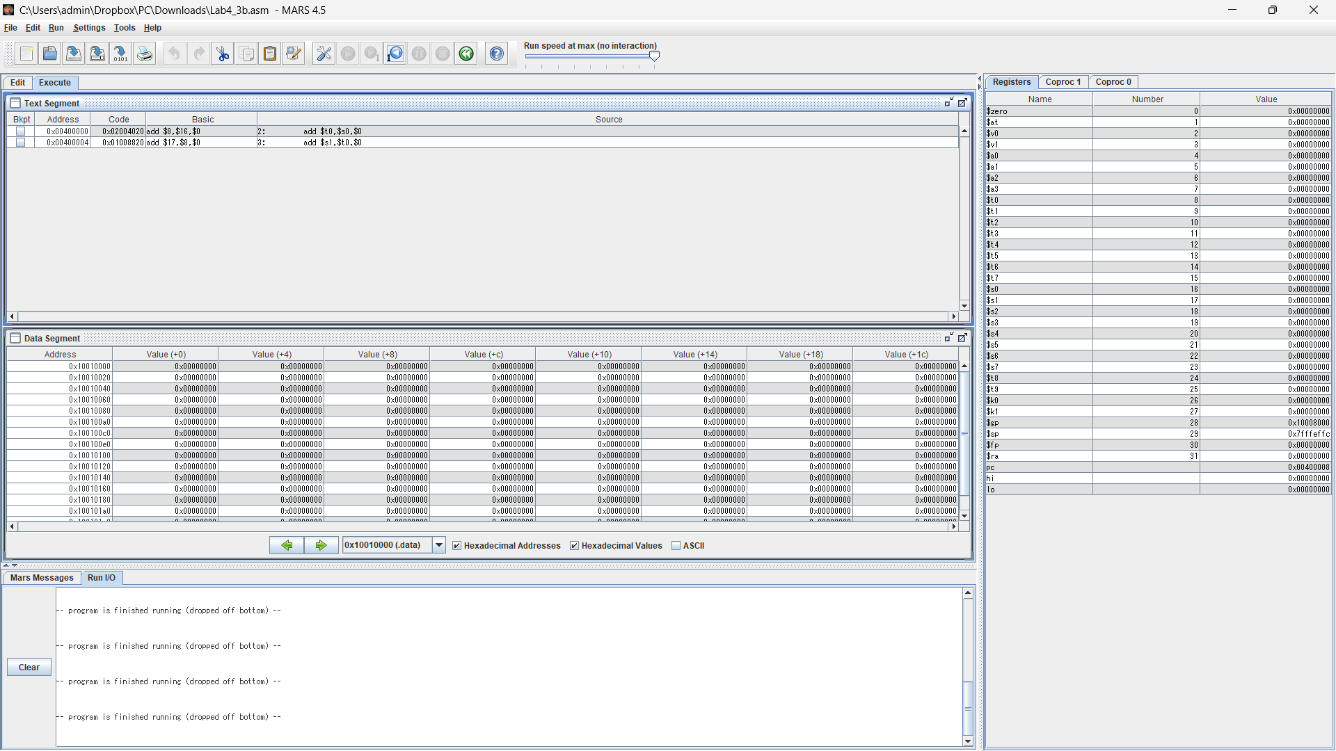
.text
add $t0,$s0,$0
add $s1,$t0,$0
c,
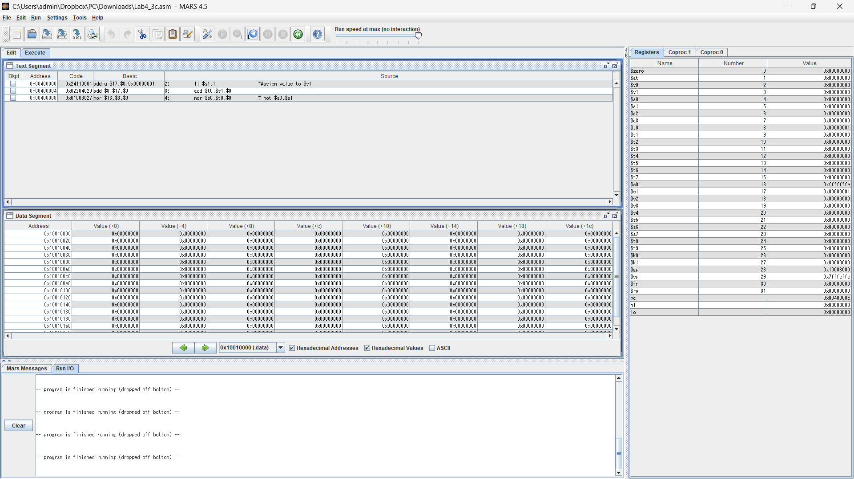
.text
li $s1,1 #Assign value to $s1
add $t0,$s1,$0
nor $s0,$t0,$0 # not $s0,$s1
d,
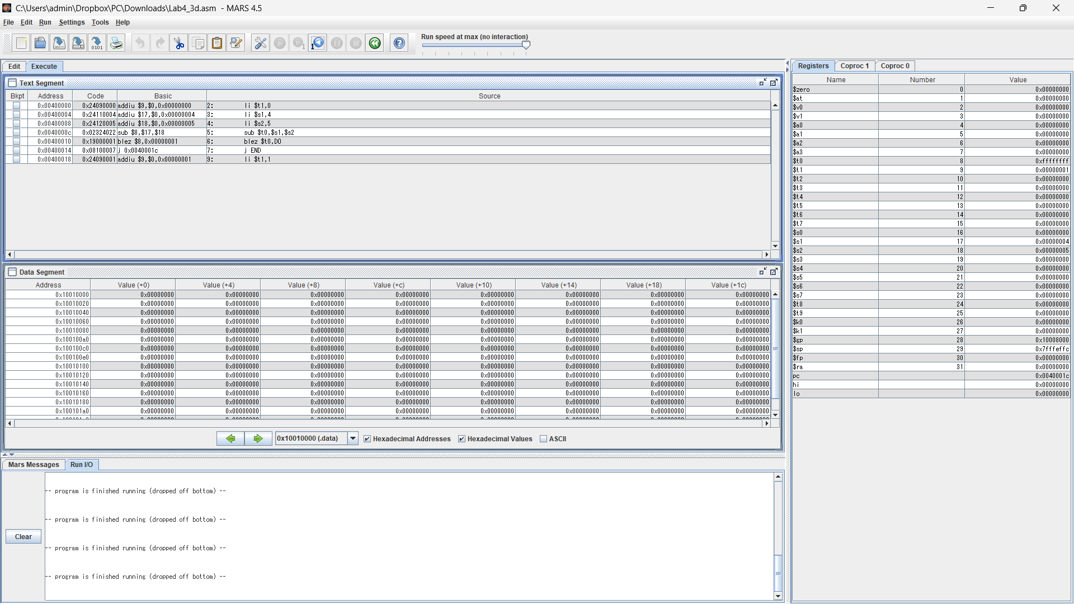
.text
li $t1,0
li $s1,4
li $s2,5
sub $t0,$s1,$s2
blez $t0,DO
j END
DO:
li $t1,1
END:

Assignment 4
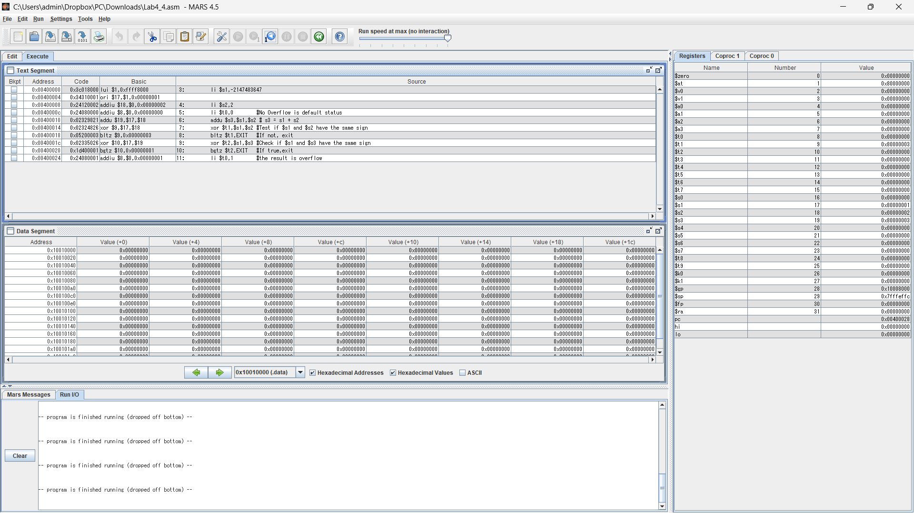
.text
start:
li $s1,-2147483647
li $s2,2
li $t0,0 #No Overflow is default status
addu $s3,$s1,$s2 # s3 = s1 + s2
xor $t1,$s1,$s2 #Test if $s1 and $s2 have the same sign
bltz $t1,EXIT #If not, exit
xor $t2,$s1,$s3 #Check if $s1 and $s3 have the same sign
bgtz $t2,EXIT #If true,exit
li $t0,1 #the result is overflow
EXIT:

Assignment 5
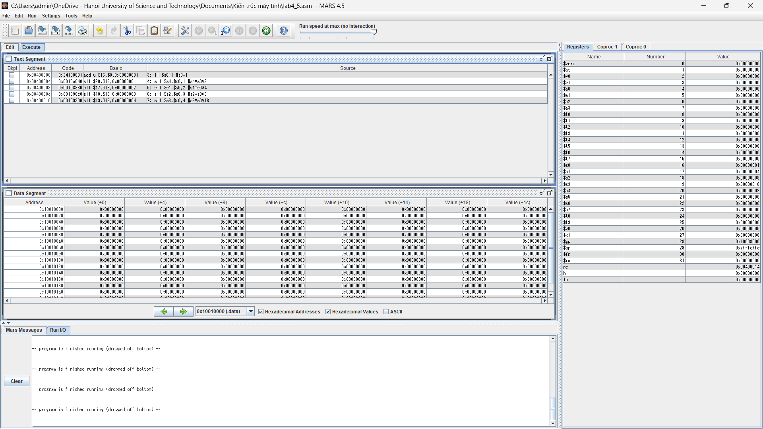
#Laboratory Exercise 4, Home Assignment 3
.text
li $s0,1 #s0=1
sll $s4,$s0,1 #s4=s0*2
sll $s1,$s0,2 #s1=s0*4
sll $s2,$s0,3 #s2=s0*8
sll $s3,$s0,4 #s3=s0*16

